PROBLEM STATEMENT

**Ideated by (Name):** Shubhendu Shekhar

**Subject:** Physics

**Title (Concept/Chapter/Question):** Work and Energy, Law of conservation of energy

**Description:**

**Energy**, in physics, is the capacity for doing work. It may exist in potential, kinetic, thermal, electrical, chemical, nuclear, or other various forms.

In physics, a force is said to do **work** if, when acting on a body, there is a displacement of the point of application in the direction of the force. For example, when a ball is held above the ground and then dropped, the work done on the ball as it falls is equal to the weight of the ball (a force) multiplied by the distance to the ground (a displacement).

The **law of conservation of energy** is a law of science that states that **energy cannot be created or destroyed, but only changed from one form into another or transferred from one object to another.**

The simulation should demonstrate the concept of energy transformation and their conservation principles following the law ‘Energy can neither be created nor destroyed’. For example: two students, one on the ground and the other at an elevated height (maybe on the nth floor of a building). The student on the ground wants to throw a ball to his friend upstairs.

Doing this activity requires energy for its execution and as we define energy as the capacity to do work, boy must have sufficient energy to do work against gravity. So, whether he can successfully pass the ball to his friend or not depends on how much energy is transferred to the ball by the student (on the ground).

**Assumptions:**

We assume that whatever energy is transferred to the ball by the student comes from an external source and there is no dissipation in between i.e. the entire amount of energy he intakes is used in doing work against the gravity which can be estimated by the gain in gravitational potential energy of the ball. To quantify the amount of this external energy, we use jars of “spinach” (our student is PopEye the sailor man!) The student transfers energy to the ball (to throw it vertically upwards to his friend) which is then transformed into the gravitational potential energy of the ball.

**Formulae / Equations required:**

Energy required by the ball to reach a certain height(h) = (mass of the ball, **m**) x (acceleration due to gravity, **g**) x **h**

The height **h** (to which the ball has to reach (or) the height from the ground where his friend stands) = **n+1** (We assume the height of each floor to be 1m and the second student stands on the nth floor)

Energy that can be transferred to the ball after consuming ‘x’ jars of spinach = **Ex** (E = Energy content of each jar of spinach)

**Parameters to be varied:**

n (the floor to which the ball has to reach)- in metres(m)

E (Energy content of each jar of spinach, which will remain a constant for the jar.)- in joules(J)

x (no. of jars of spinach that have been consumed)

m (Mass of the ball) (Kg)

**Initial conditions:**

n = 9

E = 1 J

x = 0

m = 1 kg

**A solved example:**

Assume that the student who receives the ball is at the 9th floor (h = 10 metres).

So the energy required to throw the ball = mgh = mg(n+1) = 1 x 10 x (9+1) = 100 J [ g = 10 m/s.s]

The purpose of the spinach jars is to provide energy to the thrower. The energy gained is a direct function of the number of Spinach jars consumed. Therefore, total energy gained = E*x, where x is the number of jars consumed.

**Template:** 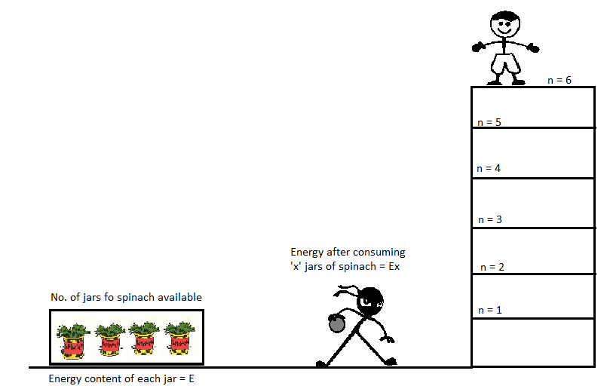

**Use cases:**

At any stage in the simulation, once “n”, “m”, “x” and “E” are fixed, we have the following parameters:

1. Energy that can be transferred to the ball (after consuming ‘x’ jars) = Ex.
2. Energy required by the ball to reach the nth floor = mgh = mgn [h = n, the number of the floors the ball needs to be thrown.]

Now, following possibilities arise:

1. If Ex = mgn, the ball will exactly reach the nth floor and the friend would be able to catch it.
2. If Ex <mgn, the ball falls short, it would not reach the nth floor and so the friend cannot catch it (In fact, it would reach a height of $\frac{Ex}{mg}$)
3. If Ex >mgn, the balls go beyond the nth floor and the friend cannot catch it again. (In fact, it would reach a height of $\frac{Ex}{mg}$)

**References:** //This field shall contain references from which an idea of the simulation can be understood. This could be a website, a book or anything else. This has to be clearly mentioned.

**Other details, if necessary:**//Other simulation specific details if any, should be included here. Optional.

**Simulation tailored to:** //If it is a concept specific, mention the question numbers from the Adaptive bank.

If it is video specific, mention the subtopic. In other words, map it accordingly.

**Review Comments**: //This is for the review team. Add any suggestions or improvements to the simulation to make it better – both visually and conceptually.